How To Maintain Tahoma 31 Bermudagrass
For the most part, managing Tahoma 31 Bermudagrass is similar to maintaining any bermudgrass variety, with a few important exceptions. Overall, Tahoma 31 requires fewer inputs of water and fertilizer, stands up to drought and tolerates shade better than other bermudagrasses.
HEIGHT OF CUT
Tahoma 31 performs best at a height of cut of between 0.125-inch to 2-inches. A rotary mower may be used but a reel mower is preferred for lower heights of cut.
FERTILIZER
Tahoma 31 requires significantly less nitrogen fertilizer than other bermudagrasses. Tahoma 31 is highly effective in its use and processing of Nitrogen fertilizer. It is suggested to apply N at 50% to 75% of the amount of N commonly applied to bluegrass depending on soil conditions at the installation site. At establishment, it is recommended to apply 1 lb. of N per 1,000 sq.ft. Once established we recommend .5 lb. of N per 1,000 sq. ft. monthly during the growing season (May to September in Utah).
IRRIGATION
Tahoma 31 requires significantly less water for irrigation than other bermudgrasses. Once established, Tahoma 31 requires 50% less water than traditional Bluegrass. Depending on weather, location, and humidity, irrigate Tahoma 31 as needed at the first sign of wilt.
GENERAL BERMUDAGRASS MAINTENANCE TIPS
INTRODUCTION
The following management practices will help you care for your Tahoma 31 Bermudagrass lawn throughout the year. Location, terrain, soil type and condition, age of the lawn, previous lawn care, and other factors affect turf performance, so adjust these management practices and dates to suit your particular lawn.
MARCH THROUGH MAY
Mowing
Mow when the lawn first turns green using a rotary or reel mower set as low as possible without scalping the lawn. Mow the grass before it grows taller than 21⁄2 inches. This initial mowing will remove excess dormant tissue and establish the desired mowing height for the year. Leave nutrient-rich grass clippings on the lawn unless they are unsightly or clumped. If grass clippings are too plentiful, collect and use them as mulch.
Fertilization
Apply nutrients based on soil testing. Contact your local Extension agent for soil testing information. In the absence of a soil test, apply 1⁄2 to 1 pound of nitrogen (N) per 1,000 square feet several weeks after the lawn turns fully green (typically between mid April and late May). Choose a fertilizer with a pre-emergent herbicide to prevent weeds.
Watering
When bermudagrass is growing, supplement rainfall as needed so that the lawn gets about .5 inch of water each week. A bluish-gray appearance or wilted, folded, or curled leaves may indicate that it is time to water. Use a screwdriver or similar implement to check for proper saturation. Push the screwdriver into the soil, once you feel the soil is harder to push into take note of how far the screwdriver went into the soil If it is less than ½ inch it is likely time to water. Sandy soils require more frequent watering (about 1⁄4 inch of water every third day). In clay soils, which accept water slowly, irrigate just until runoff occurs, wait until the water has been absorbed, and begin watering again. Continue until the desired depth or amount is applied. Proper irrigation may prevent or reduce problems later in the summer. Watering between 2 a.m. and 8 a.m. decreases the incidence of certain diseases.
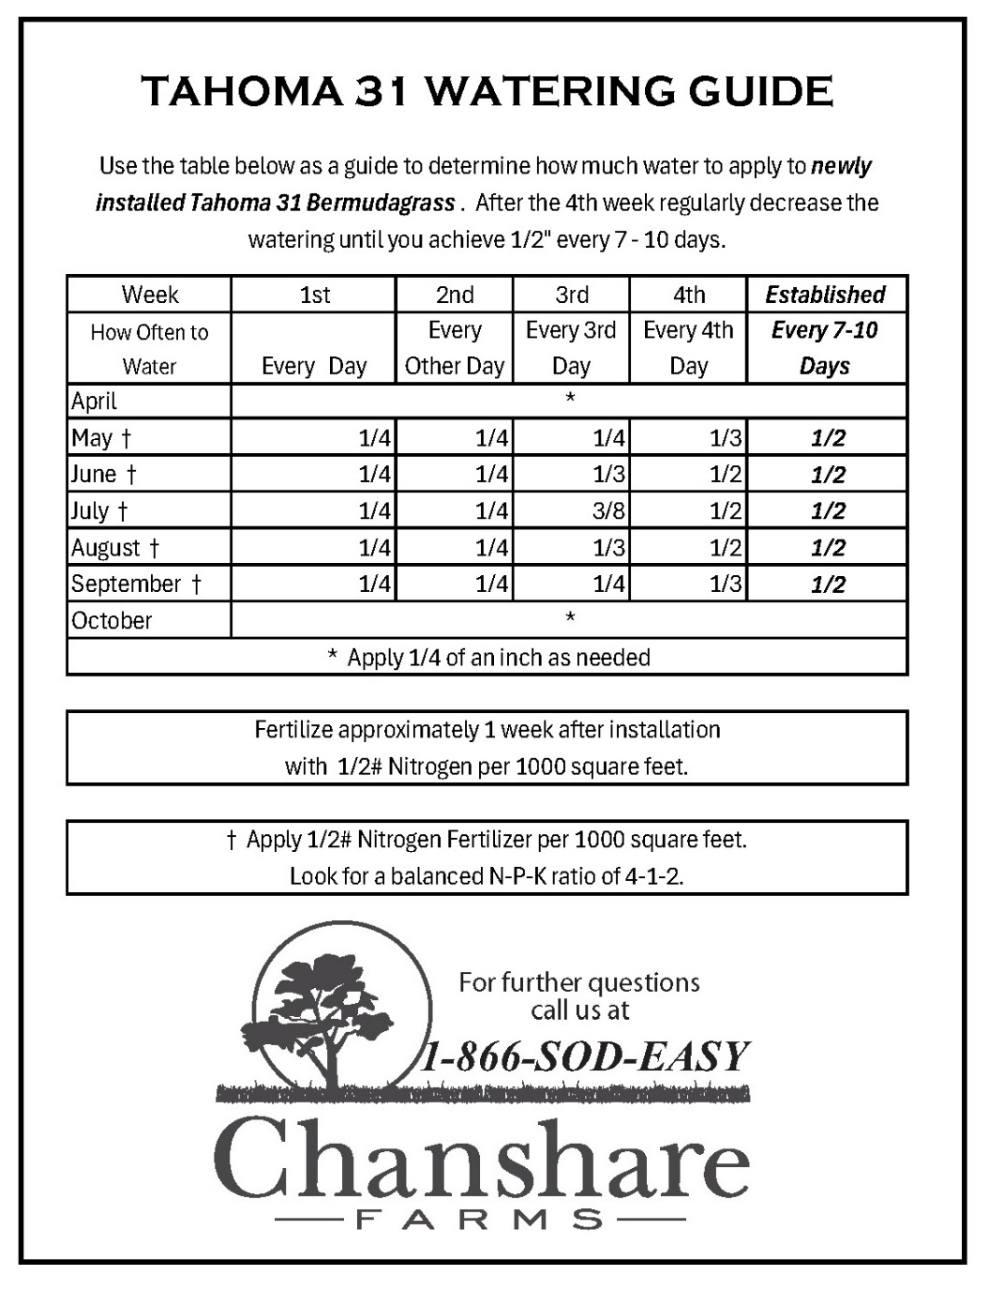

Pest Control
White grubs may be active at this time. Applying a season long grub control Mid-May is recommended in Utah.
Disease Control
As bermudagrass breaks dormancy, spring dead-spot may appear as circular patches of tan or brown sunken turf. Patches may be 2 inches to 3 feet in diameter and typically appear on turf that is 3 to 5 years old. Apply N monthly from mid-May to mid-August to promote recovery, and map affected areas for possible fungicide treatment in the fall. Core aeration and removing excessive thatch may help avoid future problems with spring dead-spot.
Thatch Removal
If thatch (a layer of undecomposed grass) is thicker than 1⁄2 inch, power rake (vertical mow) in late May. Vertical mow only after the lawn has completely greened up, or recovery will be very slow.
Renovation
In late May, start replanting bare or worn areas using sod plugs from your existing lawn or sprigs (three to five bushels per 1,000 square feet). Keep the sod or sprigs continually moist. You should be able to stick your finger down into the soil about 3 or 4 inches and feel moist soil. Be careful not to over water. You do not want it to feel muddy or sopping wet. Water your lawn twice a day until the sprigs have filled in or the sod has fully rooted. Then irrigate less frequently as needed or at the first sign of wilt.

JUNE THROUGH AUGUST
Mowing
Mow to the desired height. Bermudagrass has a very wide range of acceptable heights (5⁄8 to 2 1⁄2 inches). Maintaining a lower height will require more frequent mowing to prevent scalping. Mowing heights below 1 inch will require a reel mower and very level ground; therefore, most bermudagrass lawns are maintained between 1 and 2 1⁄2 inches.
Fertilization
Have your soil tested. Ask your local Extension agent about a free soil test. Then apply the nutrient your lawn needs. If you don’t test, apply a complete nitrogen-phosphorus-potassium (N-P-K) turf-grade fertilizer with a 3-1-2 or 4-1-2 ratio (that is, 12-4-8 or 16-4-8). For a basic level of fertility, fertilize with 1/2 pound of N per 1,000 square feet monthly.
Disease Control
If spring dead spot was a problem, apply an appropriate fungicide to problem areas at the highest label rates. Applications are most effective when soil temperatures are between 60 and 80°F. To move the fungicide into the root zone, apply with a large volume of water (5 gallons per 1,000 square feet) or water in with at least 1⁄8 inch of irrigation immediately after application. Map areas for future target applications so that you will treat only the affected areas.
Watering
Apply ½ inch of water when the Tahoma 31 shows signs of stress (generally every 6 to 7 days). Frequency of irrigation depends highly on the type of soil profile and natural rainfall. Sandy soils require more frequent watering (about 1⁄4 inch of water every third day). In clay soils, which accept water slowly, irrigate just until runoff occurs, wait until the water has been absorbed, and begin watering again. Continue until the desired depth or amount is applied. Proper irrigation may prevent or reduce problems later in the summer. Watering between 2 a.m. and 8 a.m. decreases the incidence of certain diseases.

SEPTEMBER THROUGH NOVEMBER
Mowing
Continue mowing using the March to May guidelines until several weeks before the first expected frost. Raise the mowing height 1⁄2 inch in early to mid-September and maintain a longer height to prepare the Tahoma 31 for the winter.
Fertilization
Apply no more than 1⁄2 pound N per 1,000 square feet in September, or four weeks before the first expected frost. Use a low N, high potassium fertilizer like 5-10-30, or supplement with 1 pound of potash (K2O) per 1,000 square feet four to six weeks before expected frost using 11⁄2 pounds of muriate of potash (KCl) (0-0-60) or 2 pounds of potassium sulfate (0-0-50). (The third number represents potassium.)
Watering
When bermudagrass is growing, supplement rainfall as needed so that the lawn gets about .5 inch of water each week. A bluish-gray appearance or wilted, folded, or curled leaves may indicate that it is time to water. Use a screwdriver or similar implement to check for proper saturation. Sandy soils require more frequent watering (about 1⁄4 inch of water every third day). In clay soils, which accept water slowly, irrigate just until runoff occurs, wait until the water has been absorbed, and begin watering again. Continue until the desired depth or amount is applied. Proper irrigation may prevent or reduce problems in the next growing season. Watering between 2 a.m. and 8 a.m. decreases the incidence of certain diseases.
Weed Control
Apply broadleaf herbicides to control broadleaf weeds like chickweed and henbit, as necessary. Caution: Some herbicides may affect newly sodded turf. Follow label directions.
Aeration
Aerate lawns that are subject to heavy traffic or grown on clay soils. Leave plugs on the lawn to allow them to break up and return soil back to the lawn.

DECEMBER THROUGH FEBRUARY
No maintenance is recommended through these months. As snow melts in early spring rake out any areas that look matted down to prevent snow mold and to promote earlier green up.

ACKNOWLEDGMENTS
Chanshare Farms would like to thank the turfgrass staff of North Carolina State University for developing these guidelines. You may also read this publication on the NC State website at: https://content.ces.ncsu.edu/bermudagrass-lawn-maintenance-calendar

